Sorting: https://www.geeksforgeeks.org/sorting-algorithms/

Problem: https://www.geeksforgeeks.org/problems/bubble-sort/1
C++
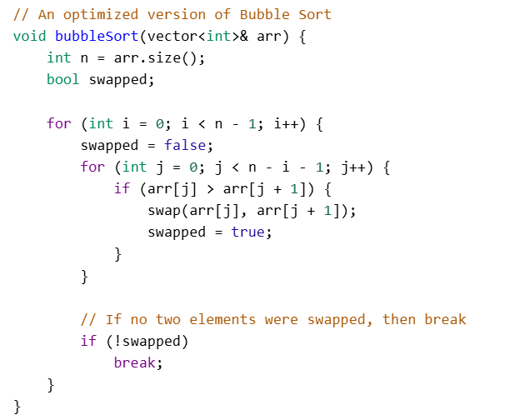
Java:
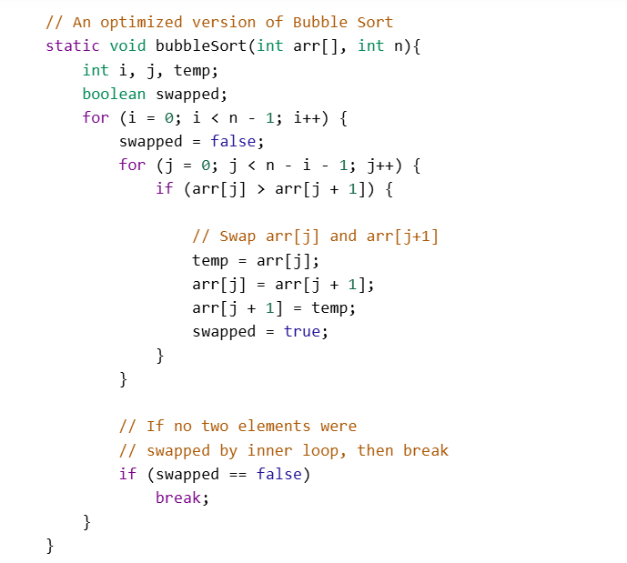

Python:
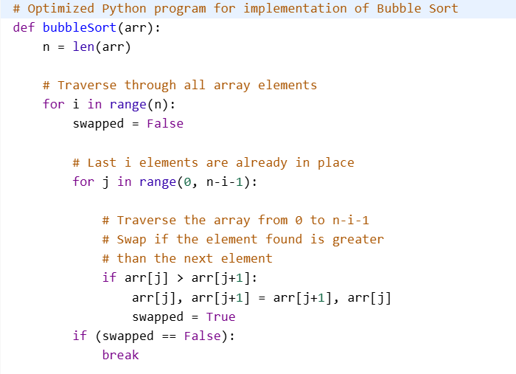

Insertion Sort:
Problem: https://www.geeksforgeeks.org/problems/insertion-sort/1
C++
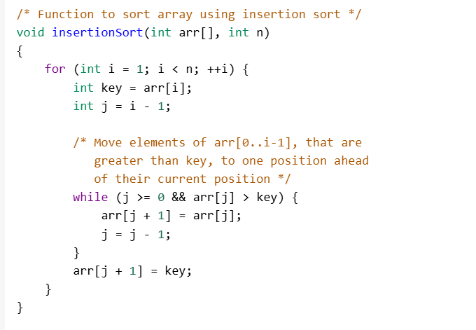
Java:
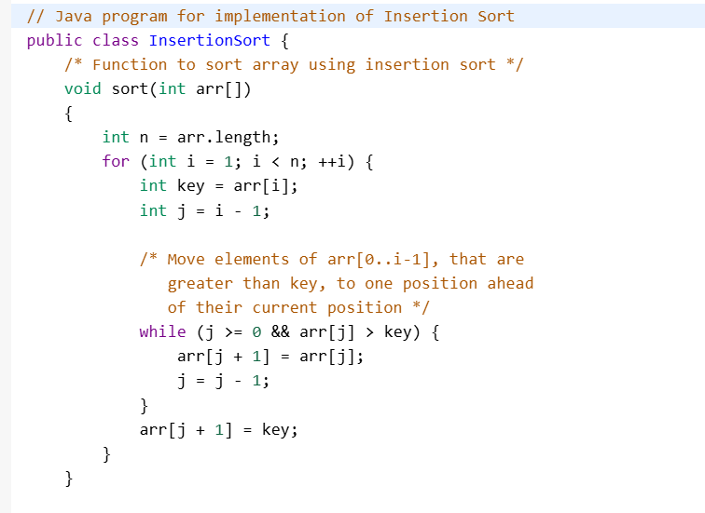
Python:
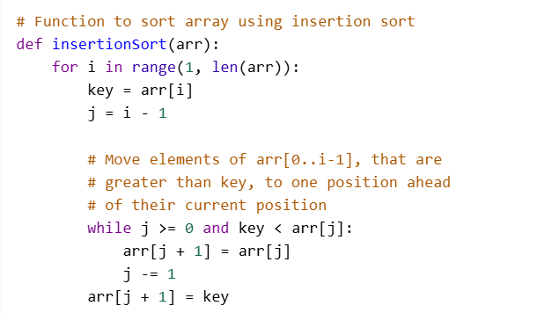

Problem:https://www.geeksforgeeks.org/problems/selection-sort/1
C++
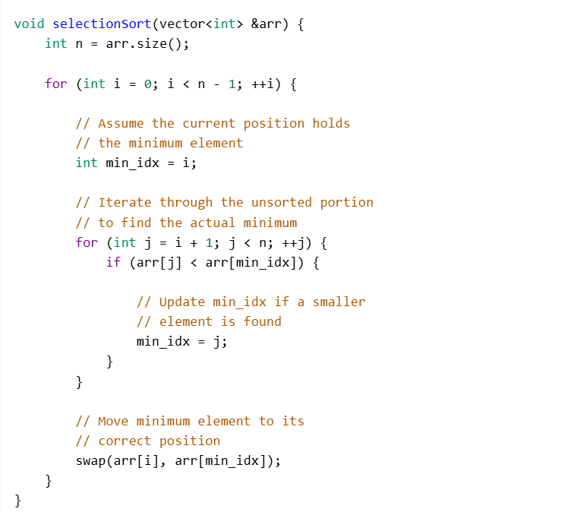
Java:
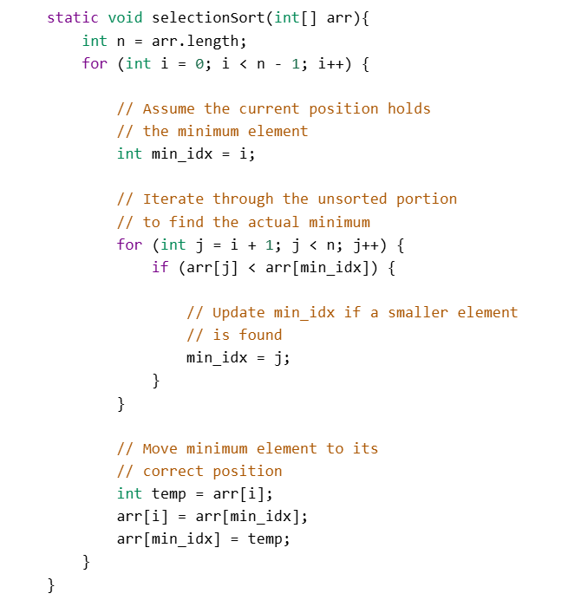

Python:
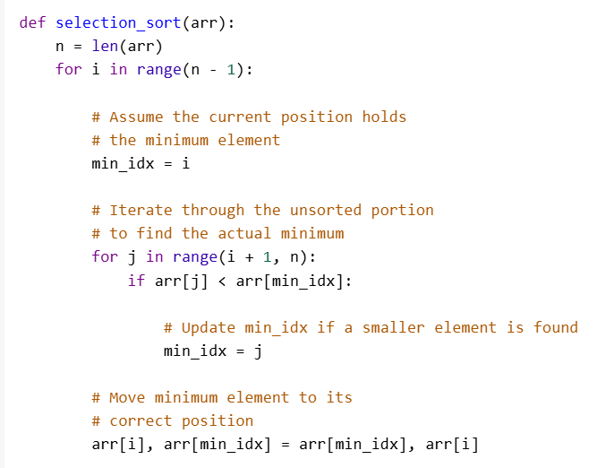

Problem: https://www.geeksforgeeks.org/problems/merge-two-sorted-arrays-1587115620/1

Solution:
Java
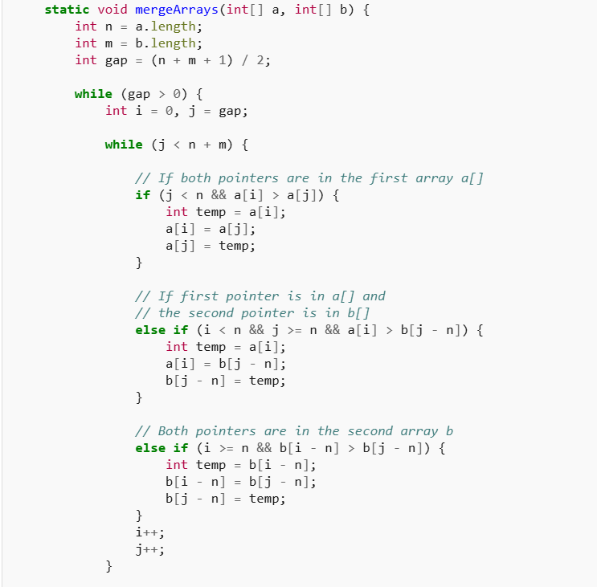
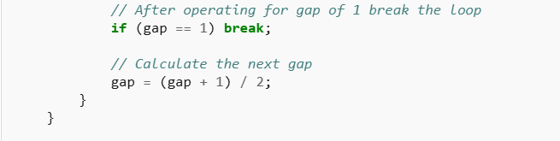
C++:
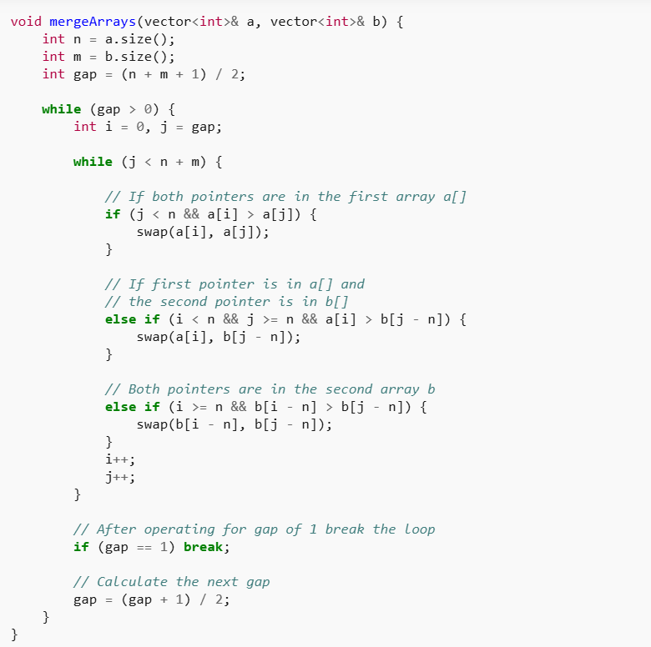

Python:
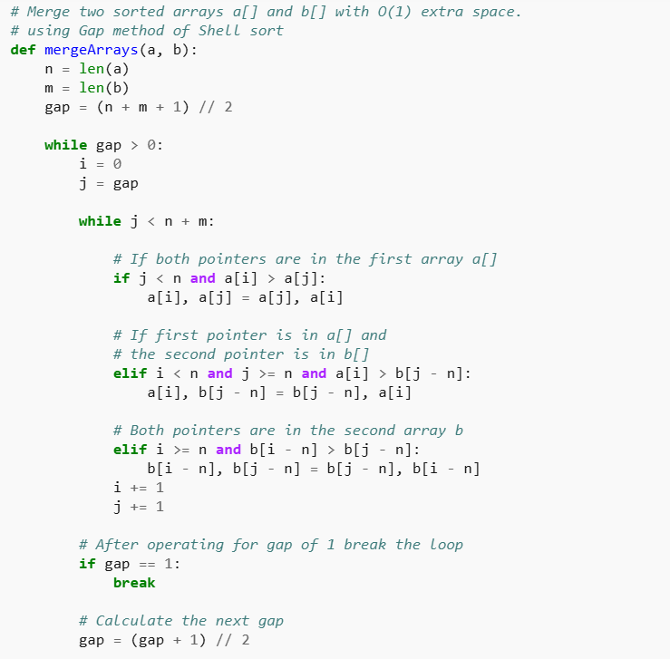

Merge Sort: https://www.geeksforgeeks.org/merge-sort/
Problem: https://www.geeksforgeeks.org/problems/merge-sort/1
C++
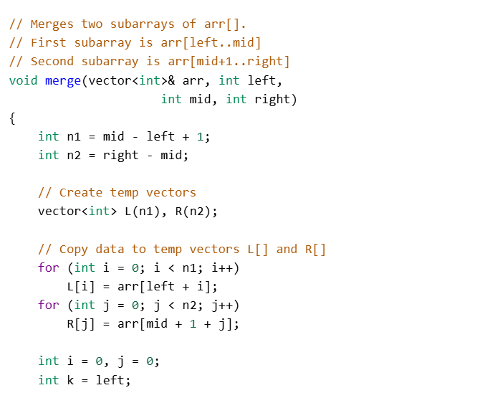
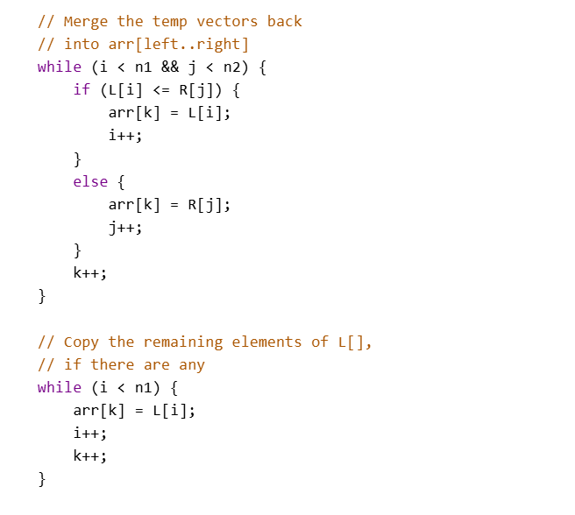

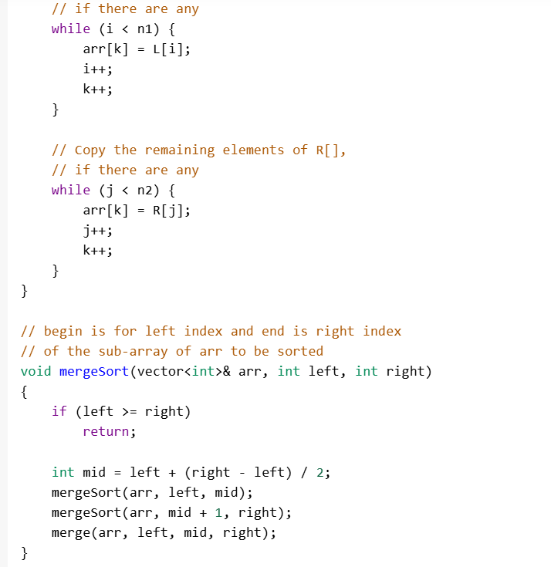

Quick Sort: https://www.geeksforgeeks.org/quick-sort-algorithm/
Problem: https://www.geeksforgeeks.org/problems/quick-sort/1
C++
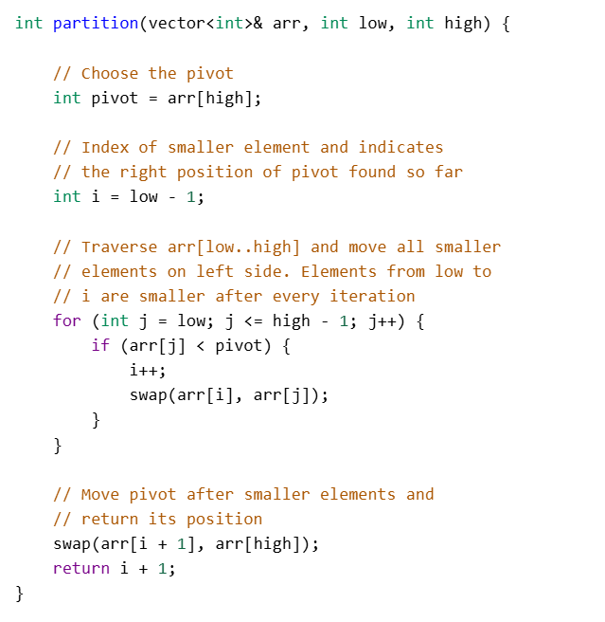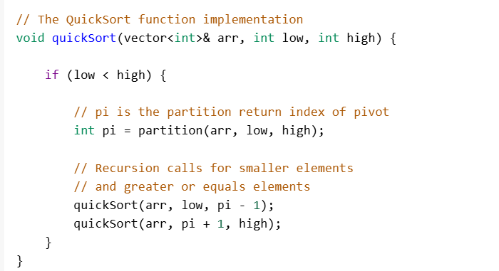

Java:
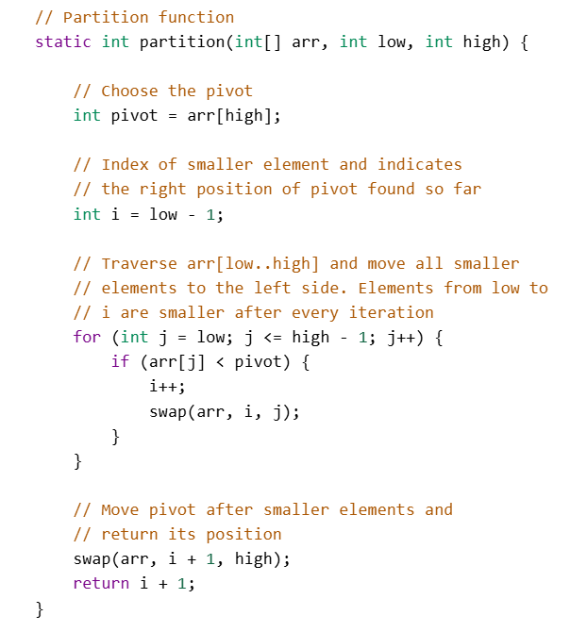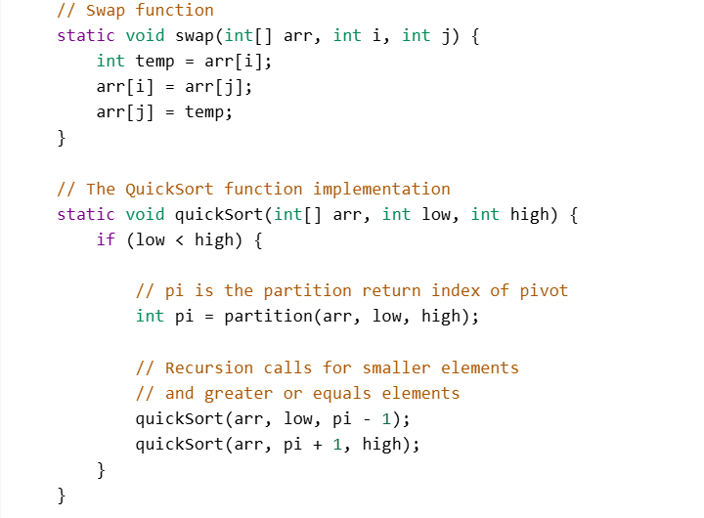
Python:
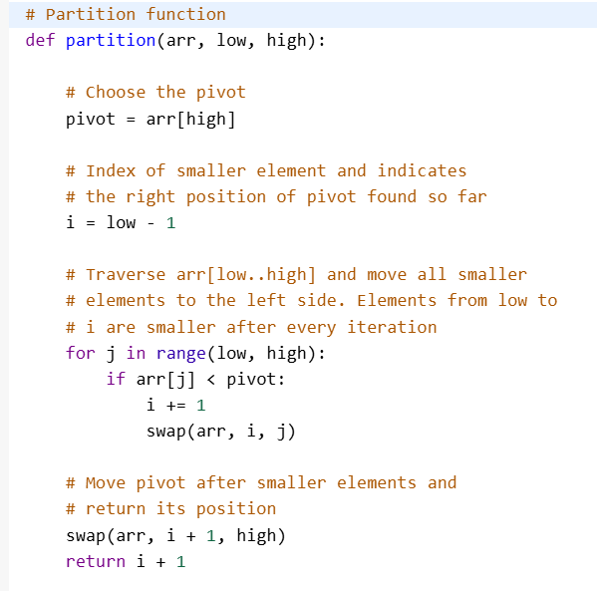
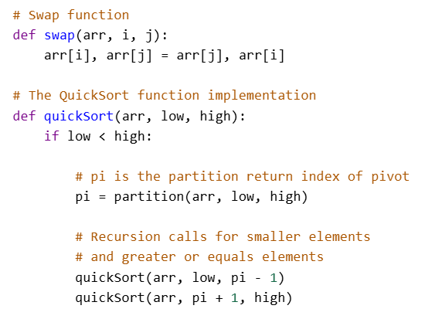

Problem: https://www.geeksforgeeks.org/problems/sort-an-array-which-contains-1-to-n-values-using-mathematical-formula/1
C++
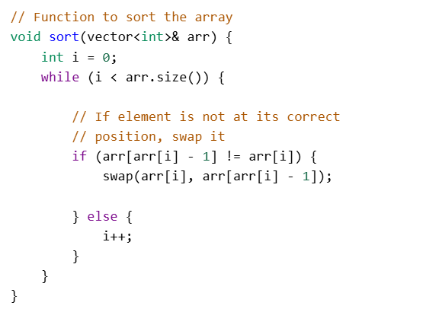
Python:
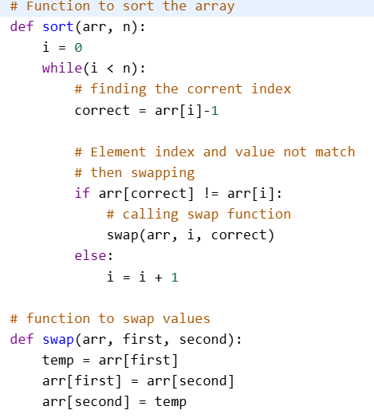

Problem: https://www.geeksforgeeks.org/problems/koko-eating-bananas/1
C++
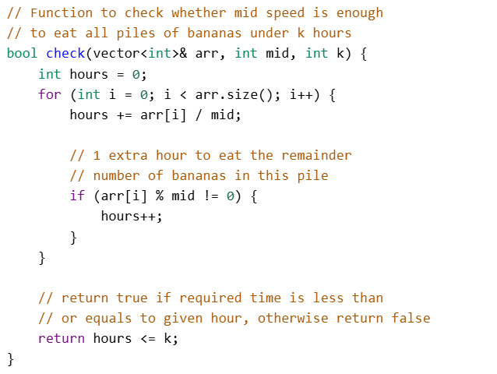
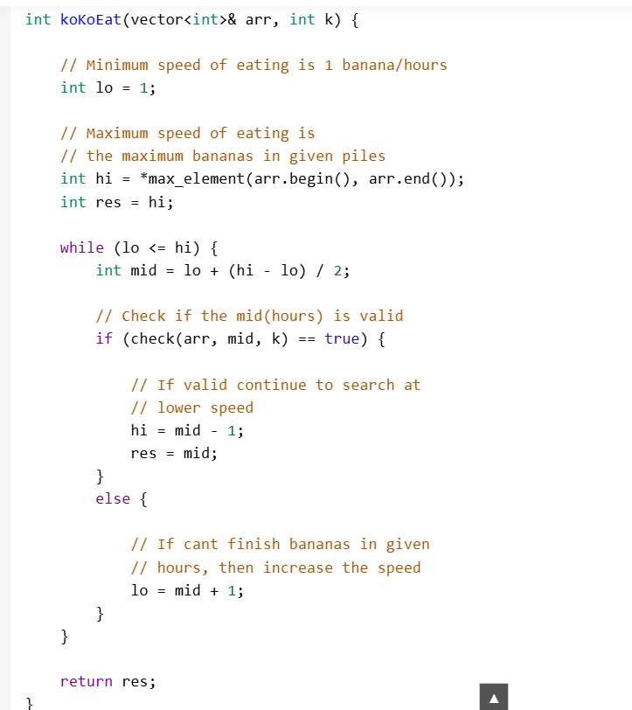

Java:
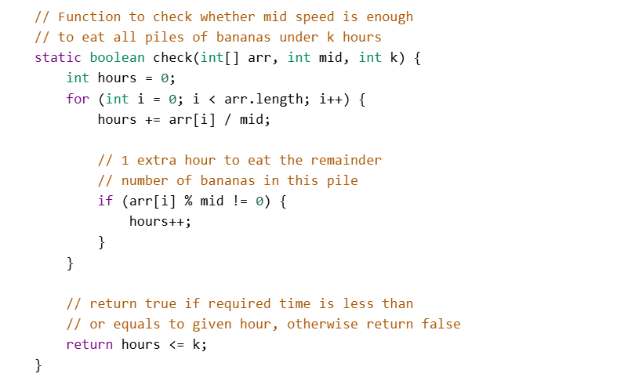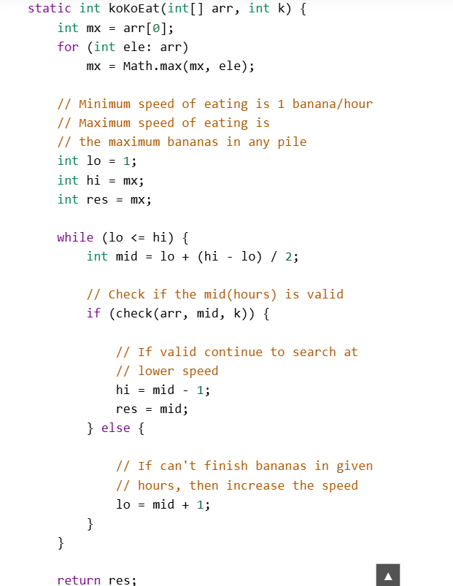


Python:
